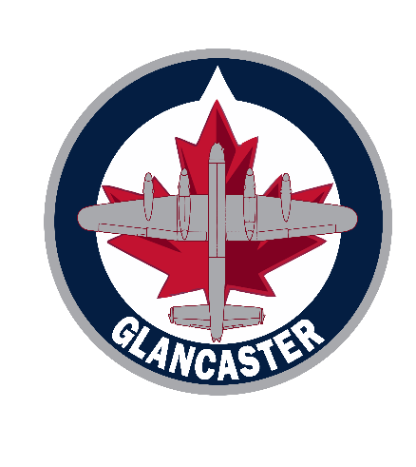
Team Official Reimbursement Form

Name of the Official Requesting Reimbursement: ______________________________________

The Team Name (ie. U10): _____________________________________________

Role of the Team Official (is. Coach, Trainer: __________________________________________

Name of course taken and date: ___________________________________________________

Amount to be reimbursed: _______________________________________________________

Mail cheque to this address: _____________________________________________________________________________

Please forward this completed form to:
treasurer@glanbrookminorhockey.com and treasurer@ancasterminorhockey.com

> Attach a copy of the receipt
> Attach a copy of the OMHA certification verifying completion of the course

