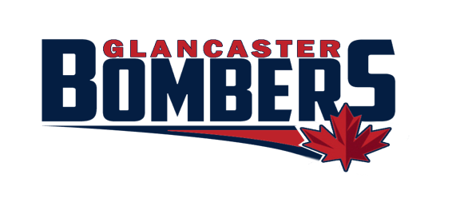
2022-23 Bombers Development Provider Roster
Application

The Glancaster Bombers are now accepting applications to join our ‘Approved Development Provider Roster’ for the upcoming 2022-23 season.
We are looking for local interested Hockey developers who want to establish some exclusivity and consistency with our teams. The Bombers are striving to become more competitive through this program.

We will be looking for and evaluating the following criteria:
- Preferred Association Pricing
- Package pricing for individual teams (1,4, and 8 sessions)
- Position specific Association affiliated development (Goalies, Forwards, Defense)
- How many instructors included in pricing (1, multiple, multiple option)
- Proof of insurance and Valid Vulnerable sector screening
- On/Off ice Coach Development
- Skating and Skill specific development
- Player specific development plans
- Age specific system implementation

If you are a Hockey Development provider and want to work with the Bombers we want to hear from you!

Application:

Please provide a brief overview of your company and any relevant history of involvement with the Bombers Association. (How many instructors do you work with? Availability? Relevant hockey instruction history.)

Please outline any position specific tactical training you feel you would excel at developing for our players and teams. (Forward, Defense, Goalie, Coach)

Please outline any position specific skills you feel you would excel at developing for our players and teams.

Please outline any preferred or package pricing you would like us to consider for our individual teams. Such as 1, 4, and 8 session pricing.

Please outline any preferred or package pricing you would like us to consider for association scheduled development (ie working with multiple teams, working with multiple position players on association scheduled ice). Such as 4, 6, 8, 10 session packages. We will be offering 2-3 1 hour sessions back to back on Saturdays/Sundays. Multiple position players or teams would be involved. Off ice mentorship opportunities are being considered in addition.
Saturday 2:15pm and 3:15pm
Sundays 1:00pm, 2:00pm, and 3:00pm

Thank you for your interest in working with our players and coaches. If you offer anything else you feel could help the Bombers players and/or coaches please include below.

Applications will be reviewed by the Bombers Competition Committee and successful applicants contacted.

