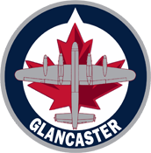
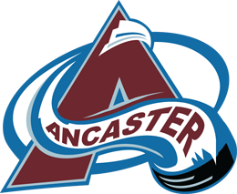

Glancaster Bombers Amalgamation Information Sessions & Vote Date
Over the past weeks and months, Glanbrook and Ancaster boards have been working collectively to create a pathway for the amalgamation and structure of the Glancaster Bombers. A lot of hard work has gone into creating and defining how the Bombers will be structured and operate. We now want to take the following opportunities to share the proposed structure with both the Glanbrook & Ancaster membership. Executives from the boards will be in attendance for the presentation and answer questions or concerns you may have.

Information Sessions:
September 12 | Glanbrook Minor Hockey Association | 7-9pm @ Glanbrook Arena
September 12 | Ancaster Minor Hockey League | 7-9pm @ Morgan Firestone
October 16 | Joint AMHL & GMHA | 10am-12pm  Mount Hope Community Centre  3027 Homestead Drive  Mount Hope

The presentation will be available on the associations’ websites and a FAQ document will be created and shared as questions arise.

Amalgamation Membership Vote:
October 22 9am – 2pm @ Glanbrook Arena + Morgan Firestone Arena

The boards of directors of AMHL and GMHA

